Connell, Amyas Douglas (1901–1980)

The New Zealand born architect Amyas Connell was responsible for a number of strikingly modern buildings, mainly houses, in 1930s England. The first of these was the gleaming white High and Over at Amersham, Buckinghamshire for Sir Bernard Ashmole (1894–1988), which is recognised as the first major Modern Movement house in England. In practice with Basil Ward (1902–1976), and joined later by Colin Lucas (1906–1984), he worked mainly on private house projects, experimenting with concrete construction to create clean-lined buildings with generous glazing. In the post-war period he completed a number of fine modern buildings in Africa, including the Aga Khan Memorial Hospital in Nairobi (1962).

Amyas Connell was born on June 23, 1901, in Eltham, New Zealand. He was the second of six children of Nigel Douglas Connell (1873–1951), who was of Scottish extraction, and his wife, Gertrude, née Weber, (1873–1950), who was born in Germany. He was educated at Stafford High School until 1916. In 1919 he was articled to Young & Fearn, an architectural practice in Wellington. Lessons through practice were supplemented by the New Zealand Institute of Architects (NZIA) professional course.

On Fearn’s recommendation, Connell left for London in 1923. Gaining experience in the offices of various architects, he also became a member of the Architectural Atelier at London University, where he admired tutor Hector Corfiato (1893–1963). In 1926 he won the Rome Prize, starting his two-year scholarship in January 1927. Ward, coming second, joined him for the first year, in which they travelled Europe, exploring ancient and modern buildings. On the brink of a third scholarship year, Connell resigned to take up his first commission High and Over in early 1929. Described as a ‘real thoroughbred of a new kind,’ this house was a gleaming white beacon on a bare hilltop of the Buckinghamshire countryside. With a Y-shaped plan, its three narrow limbs were designed to maximise the sunlight from all angles. The form is quite clearly influenced by Connell’s architectural journey thus far, fusing classical symmetry, arts and crafts design sensibilities, and an interest in the clean lines, construction techniques, and fenestration of the continental Modern Movement.
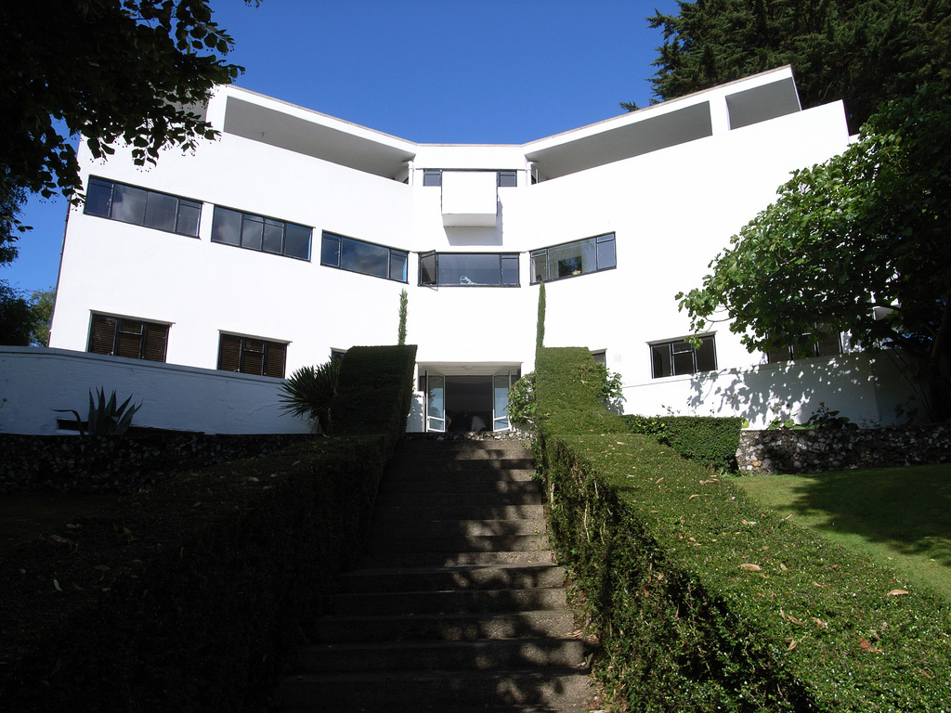
[rendel1.jpg]
High and Over, Amersham, Buckinghamshire, 1929-31. Photo by Steve Cadman. http://www.voysey.gotik-romanik.de

In a depressed economic climate he did a number of small fit-out and landscape projects. His second major commission from Sir Arthur Lowes Dickinson (1859–1935) for the quirky pink reinforced concrete New Farm at Grayswood, Surrey, did not come until 1931. In the same year Ward and Connell set up a practice, and there followed a string of private houses—two holiday homes on Hayling Island, a bungalow in Surrey, a house and small block of flats in Redhill, and the Concrete House in Bristol. There were forays into repetitive speculative housing projects adjacent to High and Over at Saltdean and on Parkwood and Frinton Estates.

An advocate of Modernism, Connell was amongst the earliest members of the Modern Architecture Research Group (MARS), the English division of Congrès Internationaux d’Architecture Moderne (CIAM), and in 1934 he was chosen by the BBC to represent the modern school of architecture in a radio debate against Sir Reginald Blomfield, who stood for tradition. Also in 1934 the English architect Colin Lucas joined the practice, bringing his expertise in modern reinforced concrete construction. Greenside (1937), Moor Park (1937), and 66 Frognal (1938) are amongst the better known of their private houses. Kent House, a development of social housing in Chalk Farm, was the only larger scale project the practice completed.

Connell, Ward, and Lucas disbanded in 1939. When war started Connell joined the Royal Engineers. From 1943 to 1946 he worked with the Ministry of Works in London as a war damage assessor. In 1947 he moved to Africa where he eventually set up the architecture, engineering, and quantity surveying group Triad. In Tanganyika he first built a sisal farm and small village community at Kange with a fine cinema as well as a number of individual houses, shop and office complexes, and a church. After moving to Nairobi in the early 1950s, Connell worked on the legislative assembly buildings, latterly the new Kenyan parliament buildings. He received an RIBA bronze medal for his Aga Khan Jubilee Memorial Hospital in Nairobi.

Connell had three children, James, Graham, and Dione, with his first wife Maud Hargroves, who he married in 1930. They split up in 1949 and Connell married Margaret Stroud in 1957 and they had a daughter named Katharine.

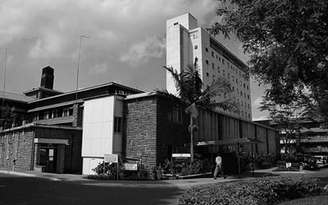
[rendelimage3.jpg]
Aga Khan Platinum Jubilee Hospital, Nairobi, Kenya (1962).
http://www.agakhanhospitals.org/nairobi/index.asp

List of Works

1931 High and Over, Amersham, Buckinghamshire.

1933 New Farm or The White House, Haslemere, Surrey.

1935 Houses on the Parkwood Estate, Ruislip, Middlesex.

1935 Kent House, Ferdinand Street, Camden, London.

1947 Shops, administrative offices, mosque and hospital, Kanga village near Tanga, Tanganyika.

1962 HH Aga Khan Platinum Jubilee Hospital, Nairobi, Kenya.

References and Further Reading

Findlay, M. (2010) Amyas Connell, ‘High and Over’ and the role of New Zealand architects in the British Modern Movement - thesis, Master of Applied Science, University of Otago.

Rendel, S. and Sharp, D. (2008) Connell, Ward and Lucas, London: Frances Lincoln.

Sharp, D. (1994) Connell, Ward and Lucas: Modern Movement Architects in England. London: Book Art.

Sharp, D. (1983) ‘The Modern Movement in East Africa: The work of Amyas Connell in Tanganyika and Kenya,’ Habitat International, 7(5/6): 311–26.

Stevens, T. (1956) ‘Connell, Ward and Lucas, 1927–1939,’ AA Journal: 112–15.

Anon., (1976) ‘Connell, Ward and Lucas,’ Architect’s Journal: 467.

Daniel, Augustus, quoted by Bernard Ashmole in Bernard Ashmole 1894-1988 An Autobiography, Kurtz, Donna (ed) Oxbow Books, Oxford, 1994, p.57

